06/07/2026
Bash scripting Task
- Create a bash script to check if a directory is available or not.
Create Directory:
$ vi check_directory.sh
Give Execute Permission
$ chmod 755 check_directory.sh
Run Bash Script
$./check_directory
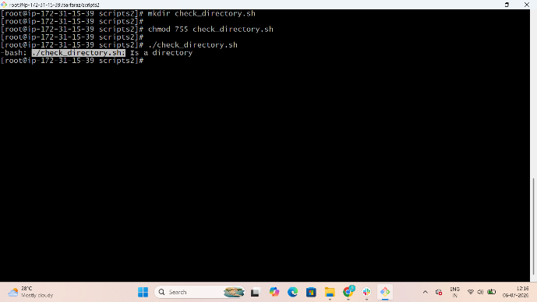

- Create a bash script to create multiple files.
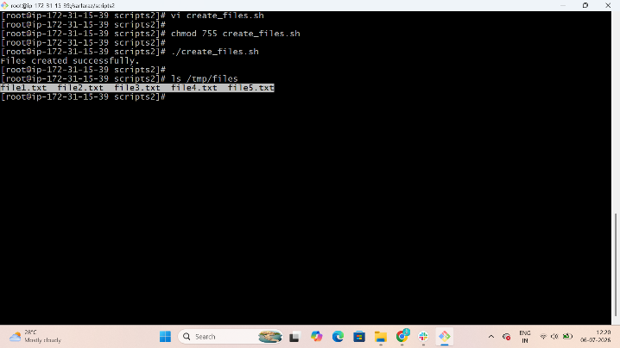
Create Directory:
$ vi create_files.sh
Give Execute Permission
$ chmod 755 create_files.sh
Run Bash Script
$./ create_files

- Create a bash script to take a backup of a directory.
Create Directory:
$ vi bachup.sh
Give Execute Permission
$ chmod 755 bachup.sh
Run Bash Script
$./ bachup
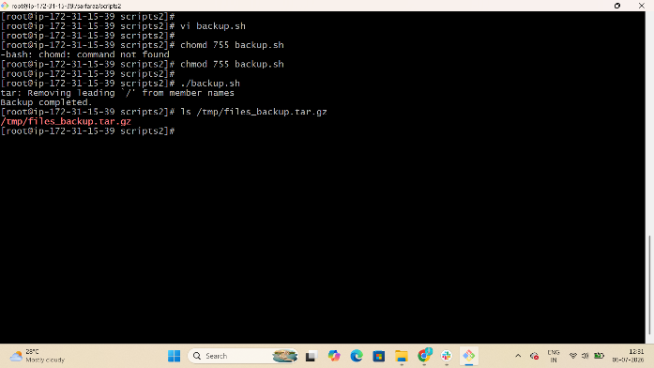

- Create a bash script to install Nginx on an EC2 server.
Create Directory:
$ vi Nginx.sh And Write your Bash Script
Give Execute Permission
$ chmod 755 Nginx.sh
Run Bash Script
$./ Nginx
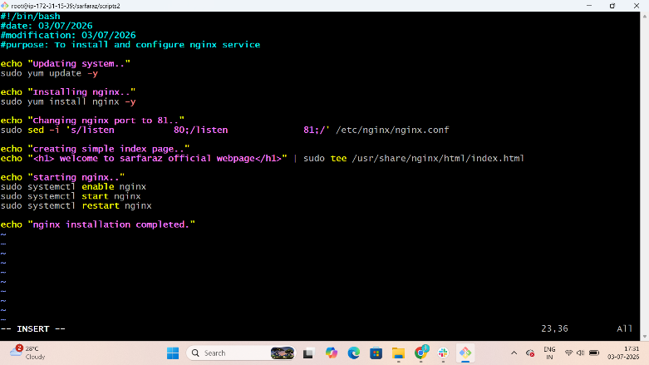
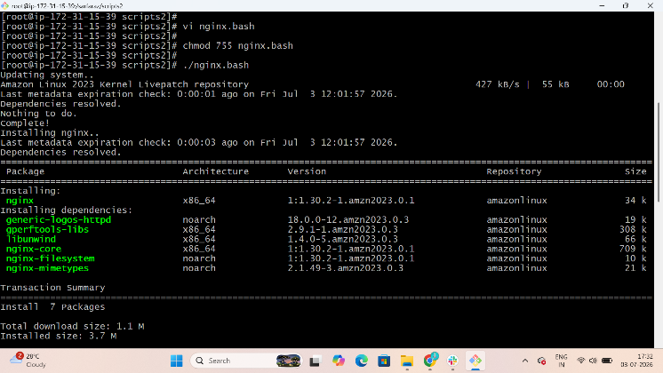

- Create a bash script to install Apache Tomcat on an EC2 server.
Create Directory:
$ vi install-tomcat.sh And Write your Bash Script
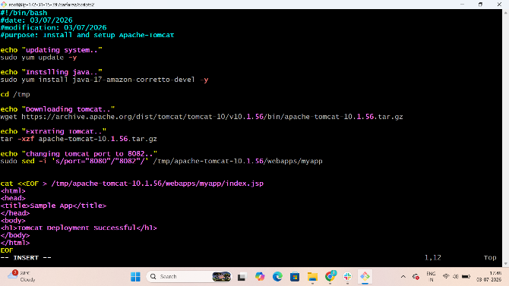
Give Execute Permission
$ chmod 755 install-tomcat.sh
Run Bash Script
$./install-tomcat
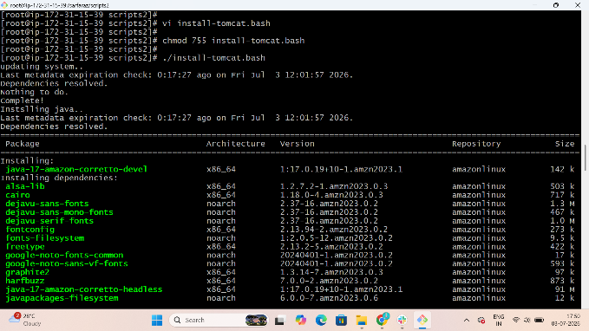

- Create a bash script to check if the Nginx service is running, if not running then script should start the service.
Create Directory:
$ vi check_nginx.sh And Write your Bash Script
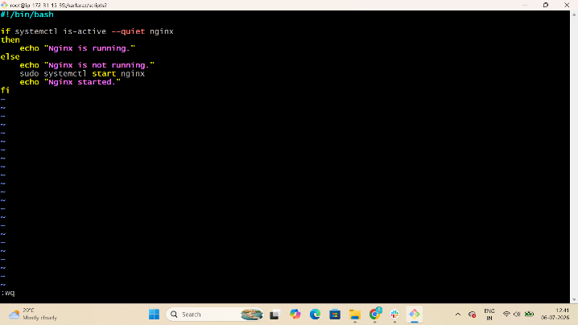
Give Execute Permission
$ chmod 755 check_nginx.sh
Run Bash Script
$./check_nginx
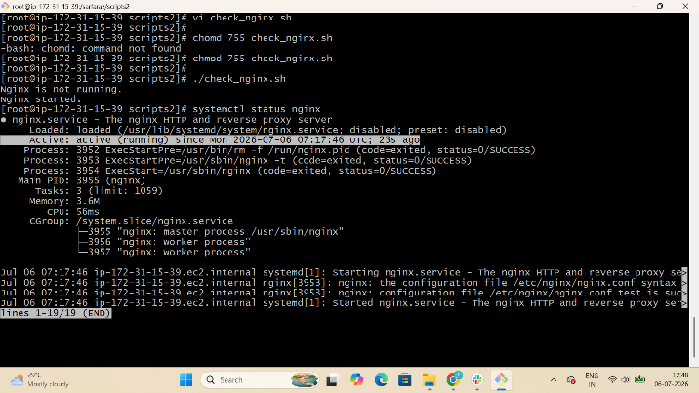
- Create a bash script for a calculator.
- Create Directory:
$ vi calculator.sh And Write your Bash Script
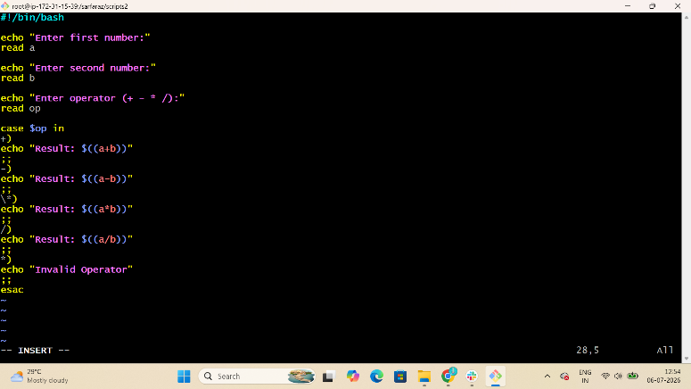
Give Execute Permission
$ chmod 755 calculator.sh
Run Bash Script
$./ calculator.sh

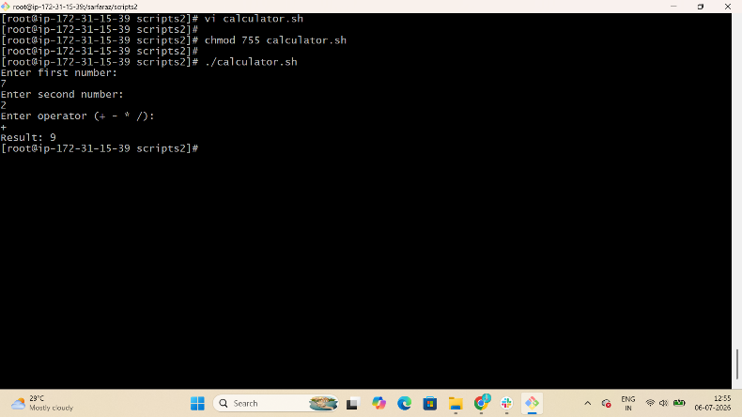
- Create a bash script to check if a directory exists, if not then create a directory.
Create Directory:
$ vi check_create.sh And Write your Bash Script
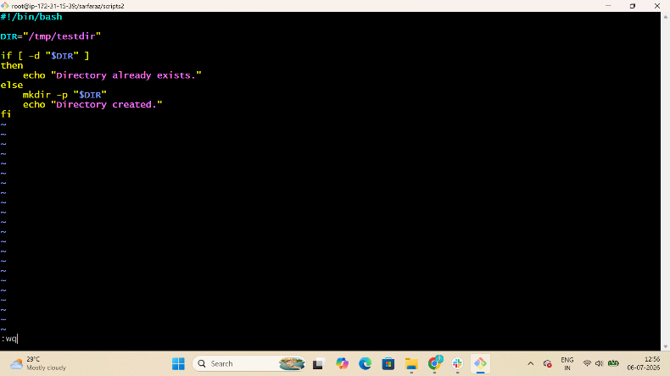
Give Execute Permission
$ chmod 755 check_create.sh
Run Bash Script
$./ check_create.sh
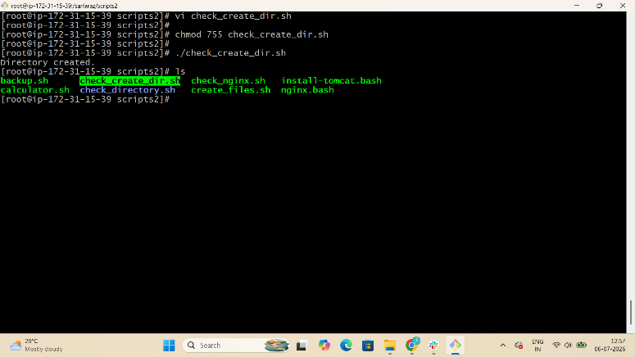

- Create a bash script to delete the last 3 lines of a file.

Create Directory:
$ vi delete_last3.sh And Write your Bash Script
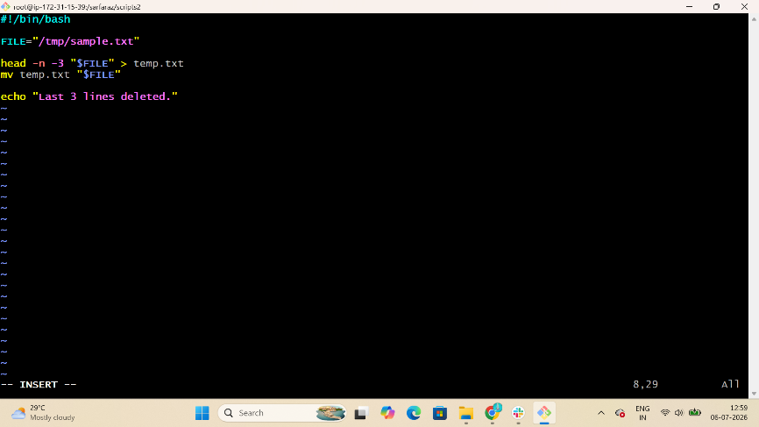
Give Execute Permission
$ chmod 755 delete_last3.sh
Run Bash Script
$./ delete_last3.sh
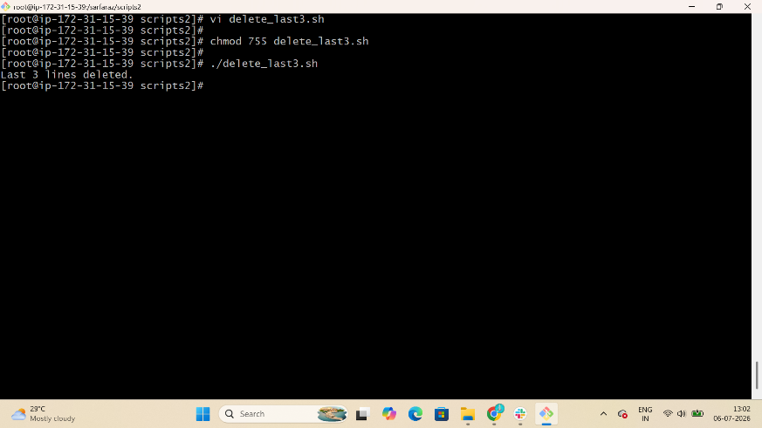

- Bash script to monitor cpu and if it is more than 80% then send email notification.
Create Directory:
$ vi cpu_monitor.sh And Write your Bash Script

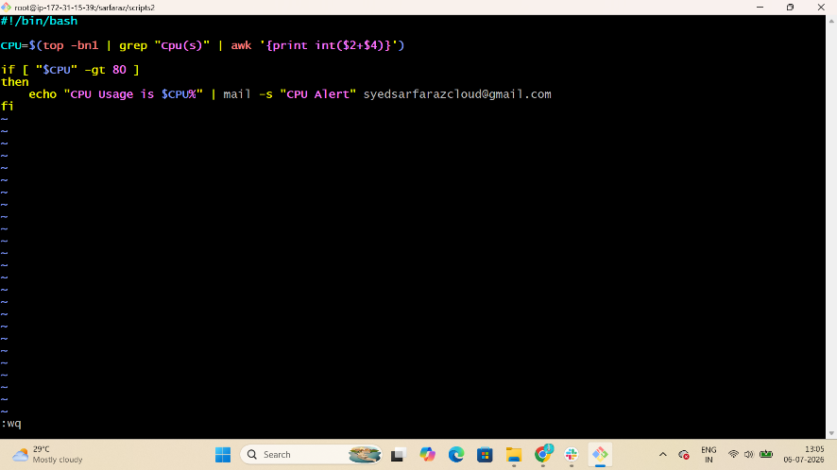
Give Execute Permission
$ chmod 755 cpu_monitor.sh
Run Bash Script
$./ cpu_monitor.sh
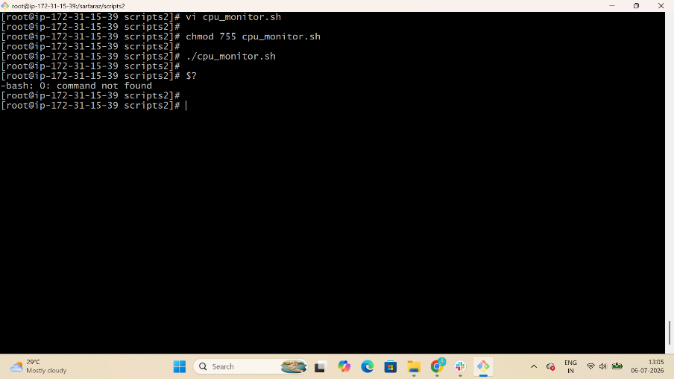

- Bash script to monitor disk space and if it is more than 80% then send email notification.
Create Directory:
$ vi disk_monitor.sh And Write your Bash Script

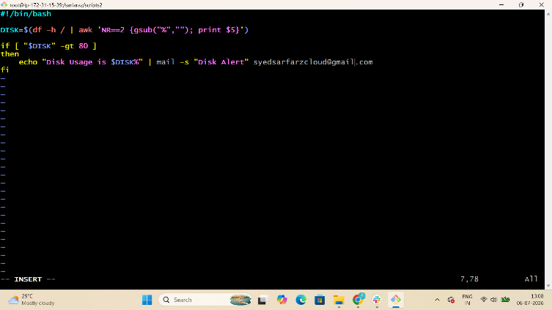
Give Execute Permission
$ chmod 755 disk _monitor.sh
Run Bash Script
$./ disk _monitor.sh
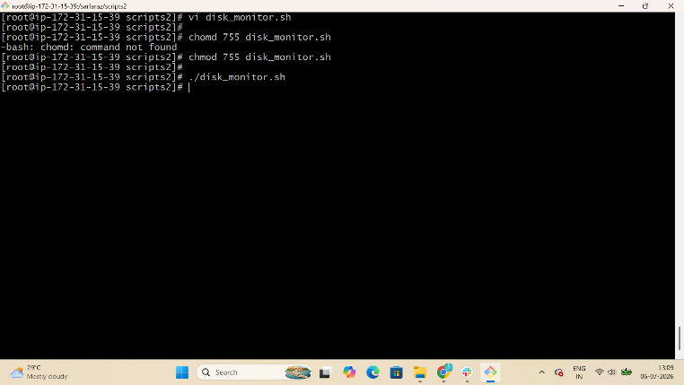

- Bash script to monitor memory and if it is more than 80% then send email notification.
Create Directory:
$ vi memory_monitor.sh And Write your Bash Script
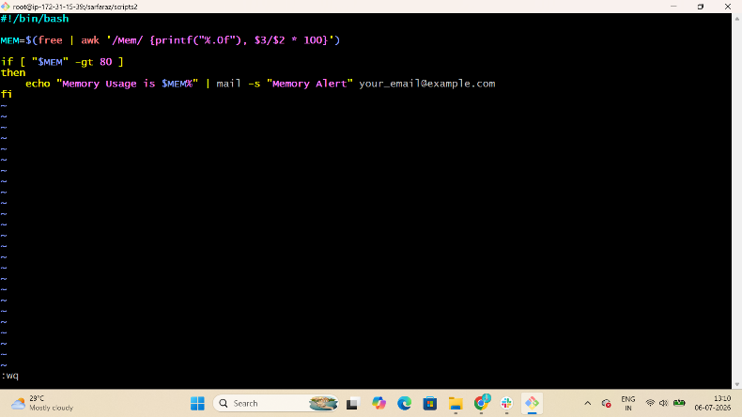
Give Execute Permission
$ chmod 755 memory _monitor.sh
Run Bash Script
$./ memory _monitor.sh
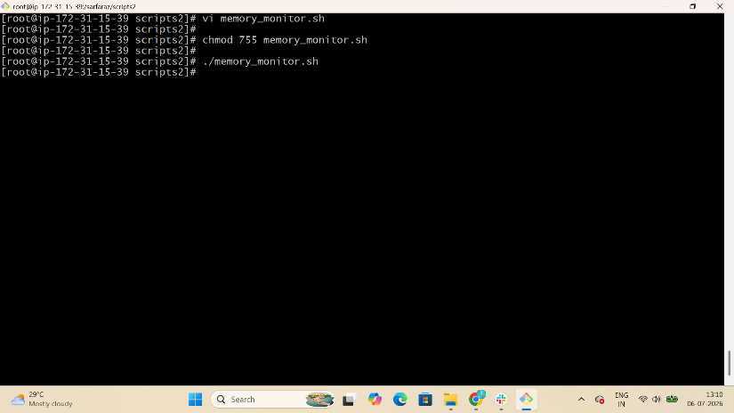
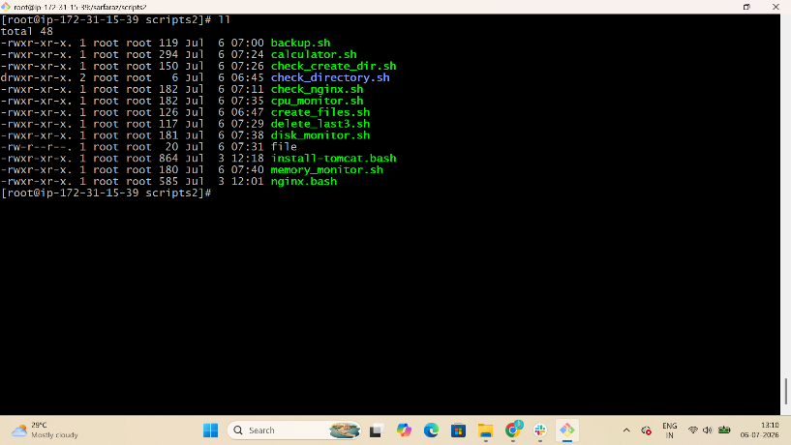

Exercise: Crontab Entries
Configure Cronjobs
$ sudo yum install cronie -y
$ sudo systemctl start crond
$ sudo systemctl enable crond
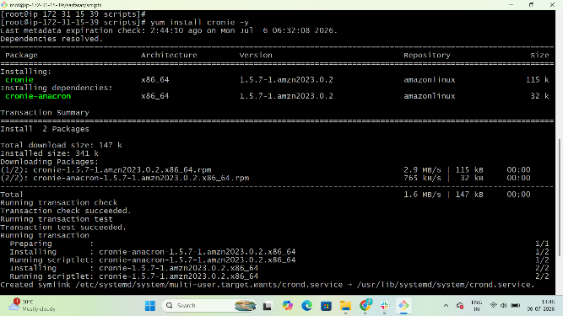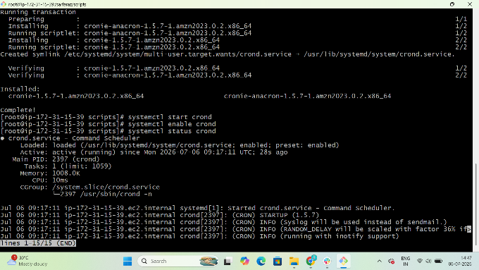

1. April 5th Midnight
Create Folder for Cronjob
$ vi myscript.sh
Give Permissions
$ chmod 755 myscript.sh
Run Script
$ ./myscript.sh
Run Cron Job
$ crontab -l
Confirm Cron-Job Status
$ cat //root/cron.log
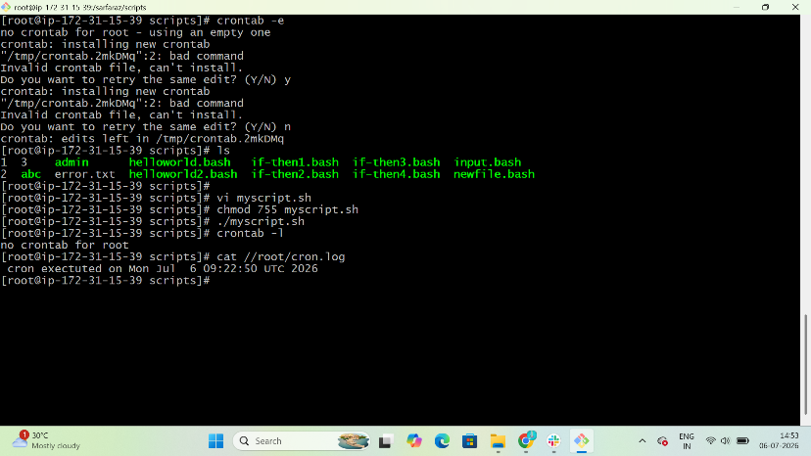

2. 5th of Every November, January, Juneif it is a Thursday
Create Folder for Cronjob
$ vi myscript.sh
Give Permissions
$ chmod 755 myscript.sh
Run Script
$ ./myscript.sh
Run Cron Job
$ crontab -l
Confirm Cron-Job Status
$ cat //root/cron.log

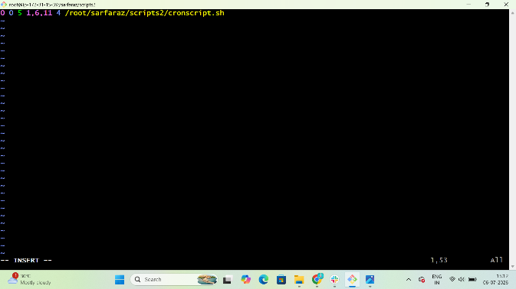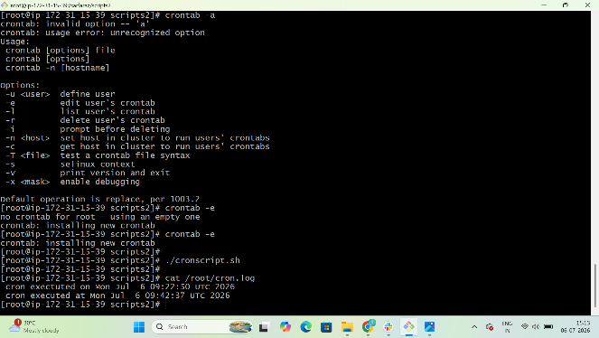

3. At05 and 27th minutesof9, 10, 11hours every day
Create Folder for Cronjob
$ vi myscript.sh
Give Permissions
$ chmod 755 myscript.sh
Run Script
$ ./myscript.sh
Run Cron Job
$ crontab -l
Confirm Cron-Job Status
$ cat //root/cron.log
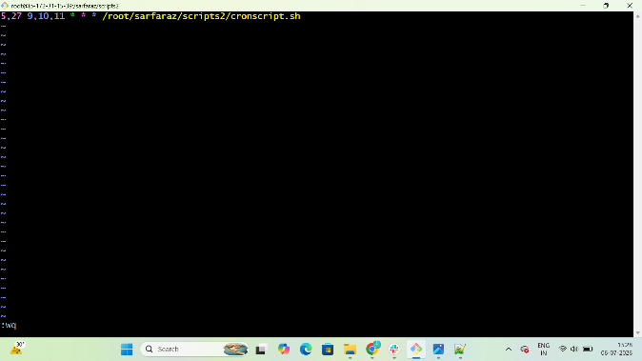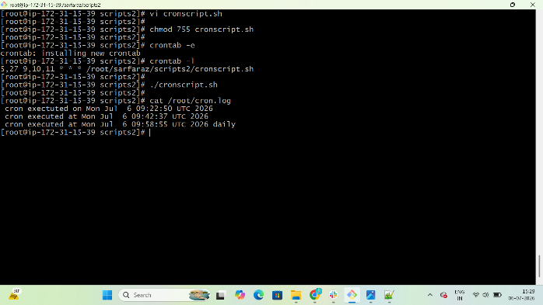

4. 34 minutesof9th houron15th August
Create Folder for Cronjob
$ vi myscript.sh
Give Permissions
$ chmod 755 myscript.sh
Run Script
$ ./myscript.sh
Run Cron Job
$ crontab -l
Confirm Cron-Job Status
$ cat //root/cron.log
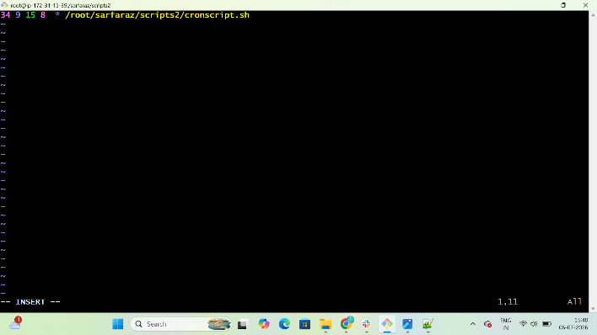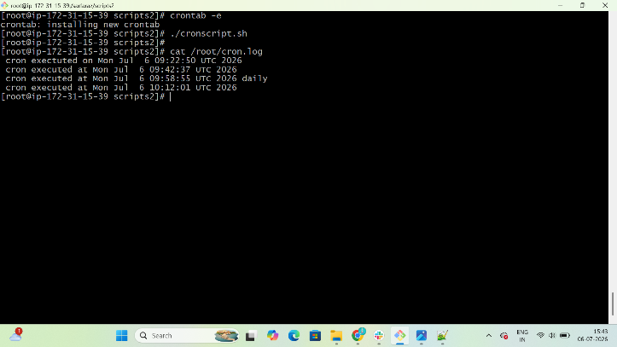

5. Every midnight
Create Folder for Cronjob
$ vi myscript.sh
Give Permissions
$ chmod 755 myscript.sh
Run Script
$ ./myscript.sh
Run Cron Job
$ crontab -l
Confirm Cron-Job Status
$ cat //root/cron.log

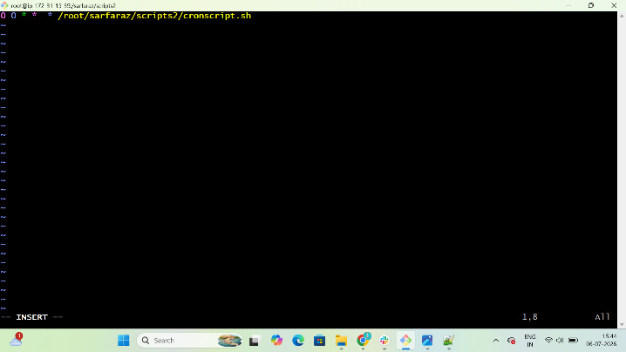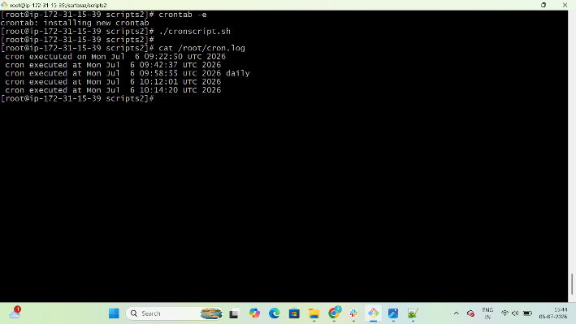

6. Every Weekend (Saturday night 11:59 PM)
Create Folder for Cronjob
$ vi myscript.sh
Give Permissions
$ chmod 755 myscript.sh
Run Script
$ ./myscript.sh
Run Cron Job
$ crontab -l
Confirm Cron-Job Status
$ cat //root/cron.log

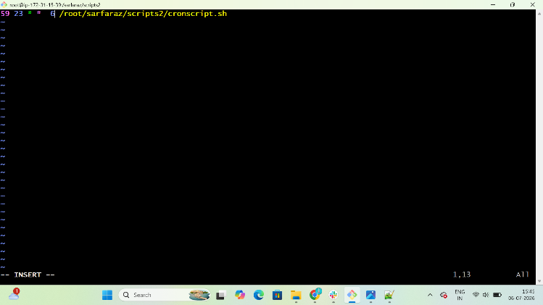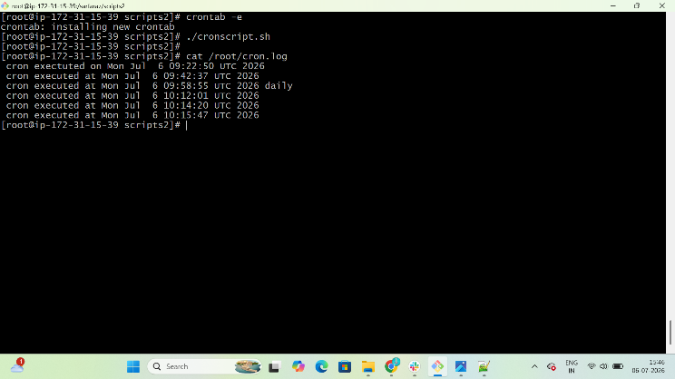

7. After every reboot
Create Folder for Cronjob
$ vi myscript.sh
Give Permissions
$ chmod 755 myscript.sh
Run Script
$ ./myscript.sh
Run Cron Job
$ crontab -l
Confirm Cron-Job Status
$ cat //root/cron.log

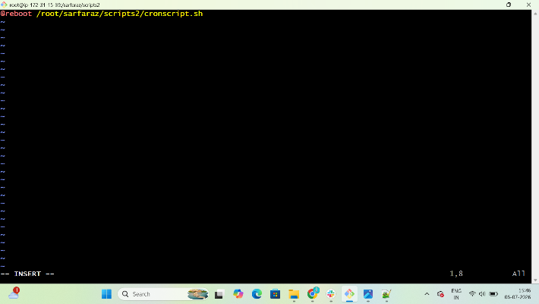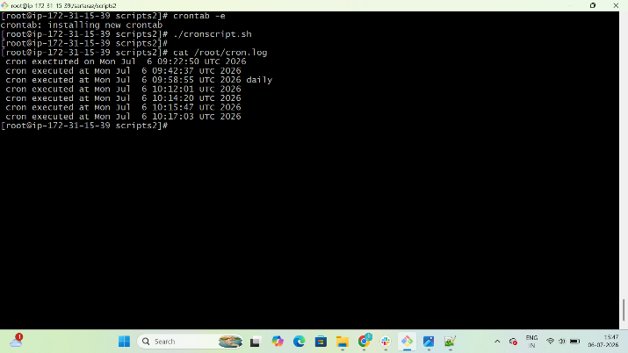

Steps to push file into github form git bash
Download git
$ sudo yum install git -y
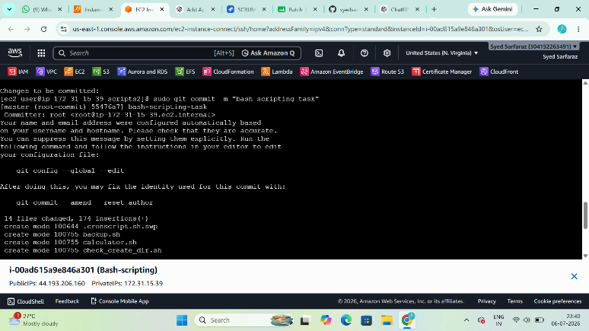
Start git by using commad
$ git init
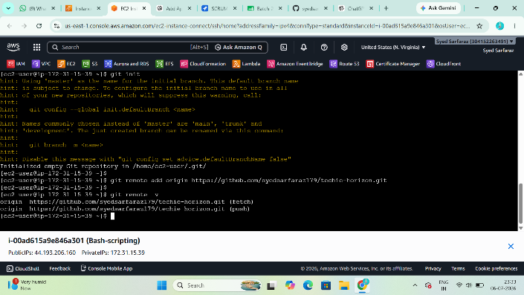
Then add files to git data base
$ git add .
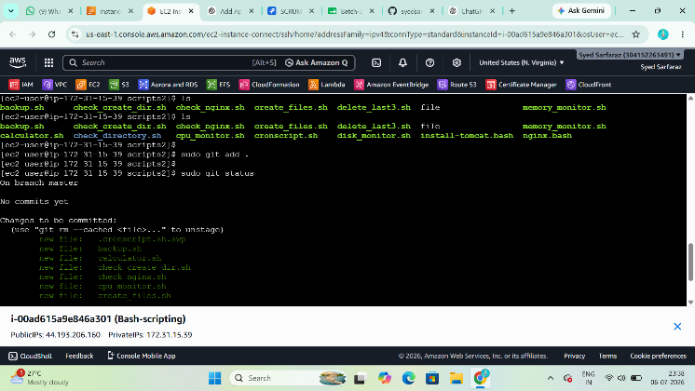

Then add repository
$ git remote add origin https://github.com/syedsarfaraz179/techie-horizon.git

Push all files to Github with Gitbash
$ git push -u origin master
